Lab 1.2 — Advanced AI Workflows using Snowpark Python Notebooks

Table of Contents
Table of Contents 2
Introduction 3
Learning Objectives 3
Prerequisites 3
Part 1 — Provisioning the Snowpark Notebook Environment 4
Step 1 — Create and Connect the Notebook 4
Step 2 — Configure Python Packages 6
Part 2 — Initializing the Snowpark Session 7
Step 1 — Import Libraries and Set Context 7
Step 1 — Define the JSON Extraction Prompt 9
Part 4 — Advanced Data Preparation: Text Chunking for Vectorization 11
Step 1 — Register the Python UDF 11
Part 5 — Persisting the Engineered Pipeline 13
Step 1 — Write DataFrame to Table 13
Knowledge Check 14
Clean Up 14
Troubleshooting 14
Symptom: ModuleNotFoundError: No module named 'snowflake.cortex' 14
Symptom: Notebook remains stuck on "Connecting..." or fails to provision. 14
Conclusion 15

Introduction
While SQL provides a powerful interface for declarative AI invocations, production-grade Machine Learning Operations (MLOps) and Retrieval-Augmented Generation (RAG) pipelines require imperative programming capabilities. Data Engineers and AI Practitioners must perform complex dataframe manipulations, parallelized inference, and advanced text processing that exceed the capabilities of standard SQL statements.
In this lab, you will deploy a native Snowpark Python Notebook within your Snowflake environment. By shifting from SQL to Python, you will leverage the Snowpark API and the Snowflake Cortex Python library to orchestrate programmatic LLM interactions. You will build a scalable data transformation pipeline that performs batch inference, extracts structured JSON entities from unstructured text, and prepares unstructured data for vectorization using custom text-chunking algorithms.

Learning Objectives
Upon completing this lab, you will be able to:
- Provision and configure a native Snowpark Python Notebook using Snowpark Container Services (Personal Compute).
- Interface with the snowflake.cortex Python module for programmatic LLM inference.
- Engineer prompts that force LLMs to return strict JSON payloads for structured data extraction.
- Author and register a Snowpark Python User-Defined Function (UDF) to chunk large text strings for downstream vector database ingestion.
- Execute parallelized transformations across Snowpark DataFrames and persist the engineered features back to Snowflake tables.

Prerequisites
Before starting, ensure you have:
- Completed Lab 1.1 and successfully created the enterprise_ai_sandbox.analytics schema and event_feedback table.
- Access to the Snowsight Web UI with the SYSADMIN (or equivalent) role.
- The SNOWFLAKE.CORTEX_USER database role granted to your active role.

Part 1 — Provisioning the Snowpark Notebook Environment
To execute Python securely where the data resides, we will create a Snowpark Notebook backed by Personal Compute. This runs Python code in a dedicated container directly on Snowflake compute nodes, eliminating data egress and providing extensive flexibility for custom Python libraries.

Step 1 — Create and Connect the Notebook
Navigate through the Snowsight UI to provision your computational workspace and attach a compute service.
- In the left navigation menu of Snowsight, click on Workspaces and select your active workspace (e.g., My Workspace).
- Click the + Add new button and select Notebook from the dropdown menu.
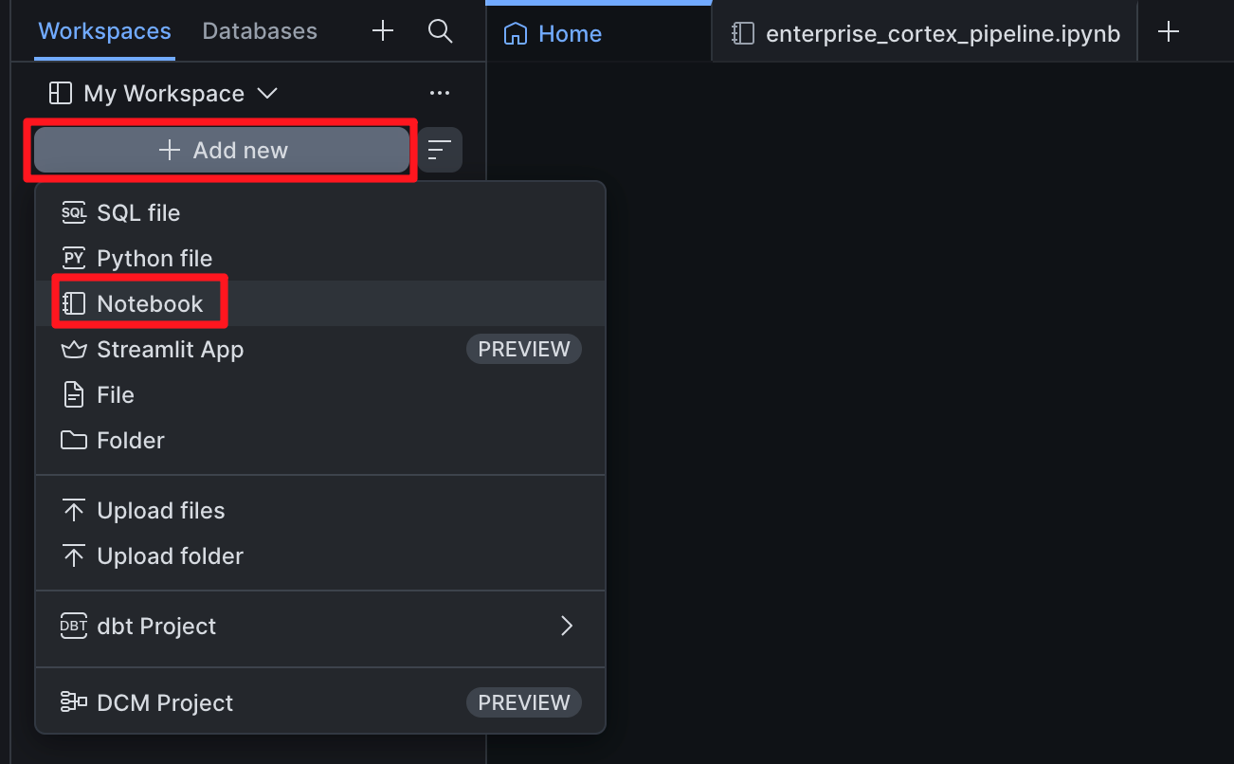
- The notebook will open immediately. Click on the default name at the top of the screen (e.g., Untitled Notebook) and rename it to enterprise_cortex_pipeline.
- You must now attach compute to the notebook. Click the Connect button at the top left of the notebook interface.
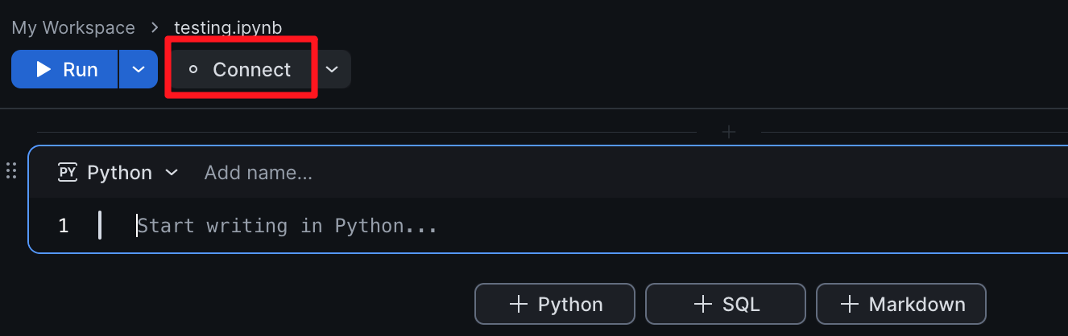
- If a dropdown appears, select Create new service. This will open the Connect your notebook modal. Configure it as follows:
  - Service name: You can leave the default generated name (e.g., YOURNAME_SERVICE_1) or name it cortex_compute_service.
  - Artifact repositories: Leave this blank/default for now.
  - Service settings: Ensure a standard CPU compute pool is selected (e.g., SYSTEM_COMPUTE_POOL_CPU).
- Click Create and connect. Wait a moment for the container service to provision. The indicator at the top left will turn green and say "Ready" when the kernel is online.
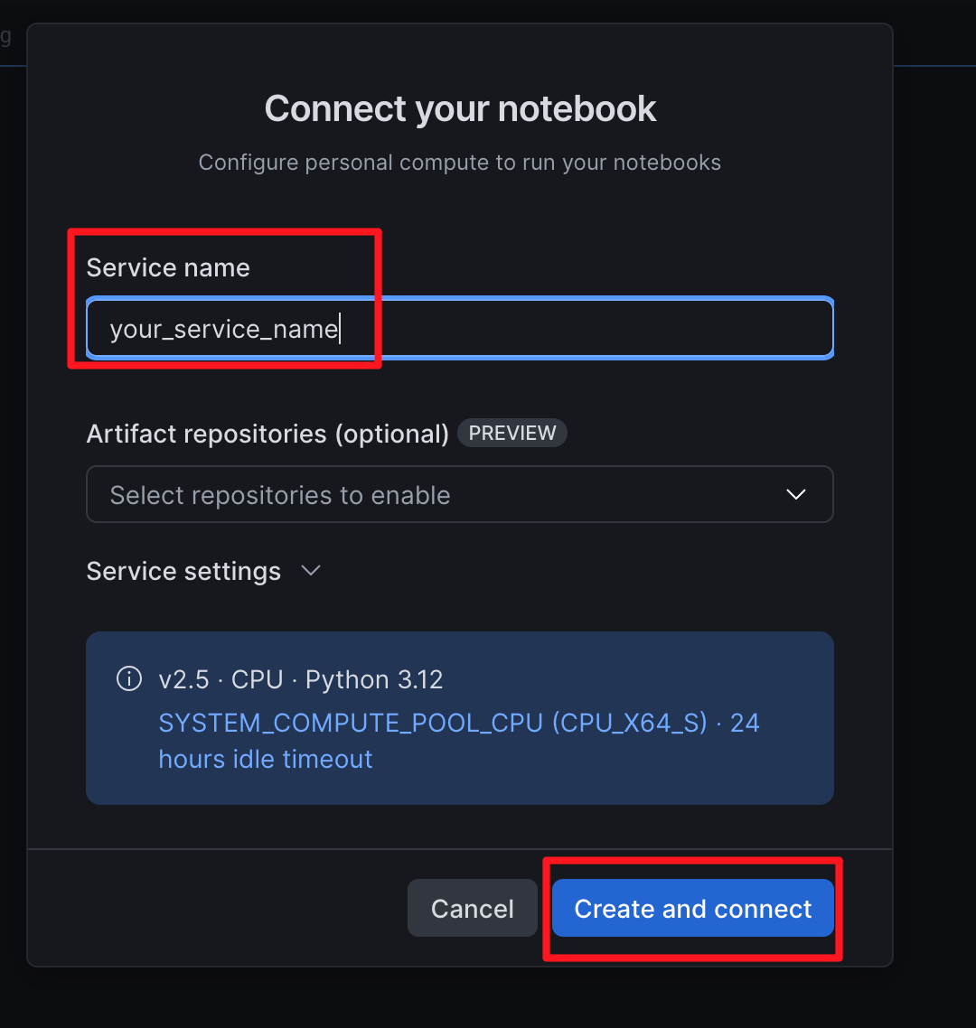

Step 2 — Configure Python Packages
Because this notebook is running inside a dedicated container service, we can use standard Python package managers to ensure our required ML libraries are present.
- In the first cell of your notebook, ensure the Snowflake ML library and Pandas are installed by running the following command:
!pip install snowflake-ml-python pandas
- Click the Run button (or press Shift + Enter) to execute the cell. Wait for the installation output to confirm the packages are successfully installed.
Note on Pip Warnings: You may see a warning indicating that the environment cannot reach external package sources, followed by multiple Requirement already satisfied messages. This is expected! Snowflake's container services securely block external internet access by default, but the base image already comes pre-loaded with popular libraries like snowflake-ml-python and pandas. The command simply verifies they are already present and succeeds without needing to download anything.

Part 2 — Initializing the Snowpark Session
Every Snowpark Notebook natively injects an active session object, accessible via get_active_session(). We will explicitly define our Database and Schema context programmatically to ensure our notebook is querying the correct location.

Step 1 — Import Libraries and Set Context
Create a new Python cell (click the + Python button) and execute the following code to establish the connection, define the database context, and inspect our existing data.
from snowflake.snowpark.context import get_active_session
import snowflake.snowpark.functions as F
from snowflake.cortex import Complete

session = get_active_session()

# Explicitly set the execution context
session.use_database("ENTERPRISE_AI_SANDBOX")
session.use_schema("ANALYTICS")

df_feedback = session.table("event_feedback")
df_feedback.show()

Expected Output:
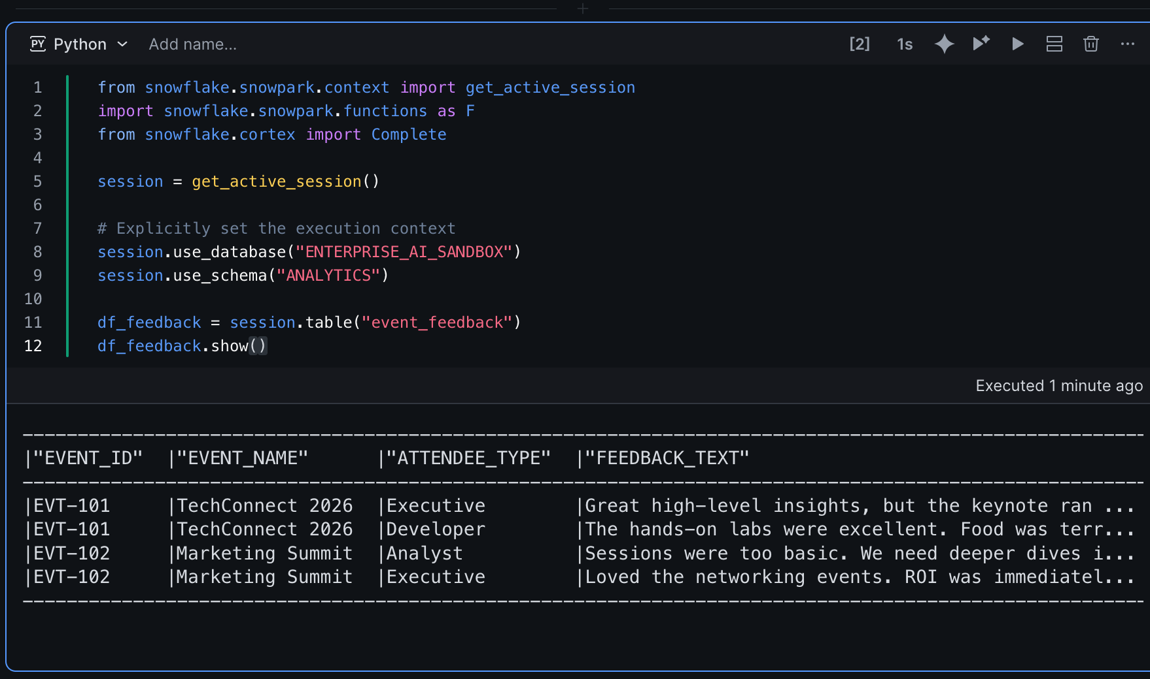

Part 3 — Batch Entity Extraction via Programmatic Prompts
In unstructured feedback, valuable metadata (like specific features mentioned or operational issues) is hidden. We will use the Cortex Python API to force the LLM to extract this data as a strictly formatted JSON array, which is ideal for downstream analytics.

Step 1 — Define the JSON Extraction Prompt
We will dynamically build a prompt string directly within the DataFrame transformation logic.
from snowflake.cortex import complete
import snowflake.snowpark.functions as F

prompt_template = """
You are a data extraction pipeline.
Analyze the following feedback text and extract two things:
1. 'sentiment': (Positive, Negative, or Neutral)
2. 'topics': (A list of specific subjects mentioned, like 'food', 'labs', 'keynote', 'networking')

Return ONLY a valid JSON object with these two keys. Do not include markdown formatting or backticks.

Feedback:
"""

df_extracted = df_feedback.with_column(
"AI_METADATA",
complete("llama3.1-8b", F.concat(F.lit(prompt_template), F.col("feedback_text")))
)

df_extracted.select("EVENT_ID", "AI_METADATA").show(max_width=100)

Expected Output:
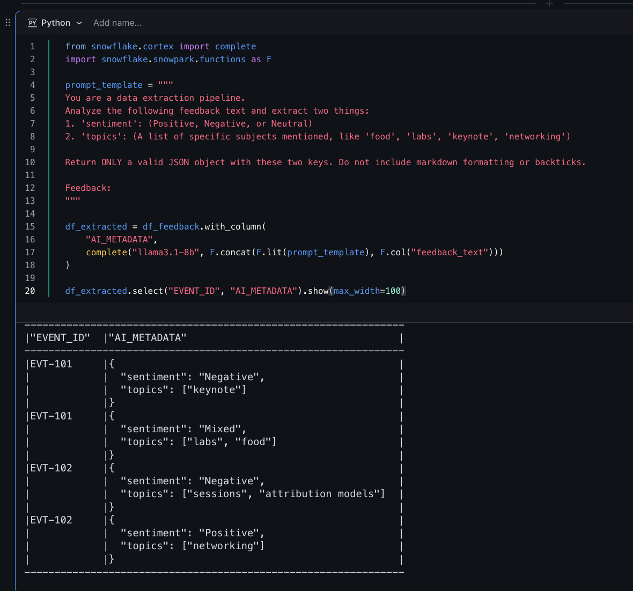

Part 4 — Advanced Data Preparation: Text Chunking for Vectorization
A critical step in modern AI architectures (specifically RAG) is chunking. LLMs have context limits, and embedding models require smaller, semantically rich blocks of text. We will build a custom Python UDF that splits text into chunks, executing directly on the Snowflake compute nodes.

Step 1 — Register the Python UDF
We use the @udf decorator to push this custom Python logic into the Snowflake execution engine. This function takes a long string and splits it into smaller segments based on character count, ensuring words are not cut in half.
from snowflake.snowpark.types import ArrayType, StringType
from snowflake.snowpark.functions import udf

@udf(name="chunk_text", is_permanent=False, replace=True, return_type=ArrayType(StringType()), input_types=[StringType()])
def chunk_text(text: str) -> list:
chunk_size = 50
words = text.split()
chunks = []
current_chunk = []
current_length = 0

for word in words:
if current_length + len(word) > chunk_size:
chunks.append(" ".join(current_chunk))
current_chunk = [word]
current_length = len(word)
else:
current_chunk.append(word)
current_length += len(word) + 1

if current_chunk:
chunks.append(" ".join(current_chunk))

return chunks

df_chunked = df_extracted.with_column("FEEDBACK_CHUNKS", F.call_udf("chunk_text", F.col("feedback_text")))

df_chunked.select("EVENT_ID", "FEEDBACK_CHUNKS").show()

Expected Output:
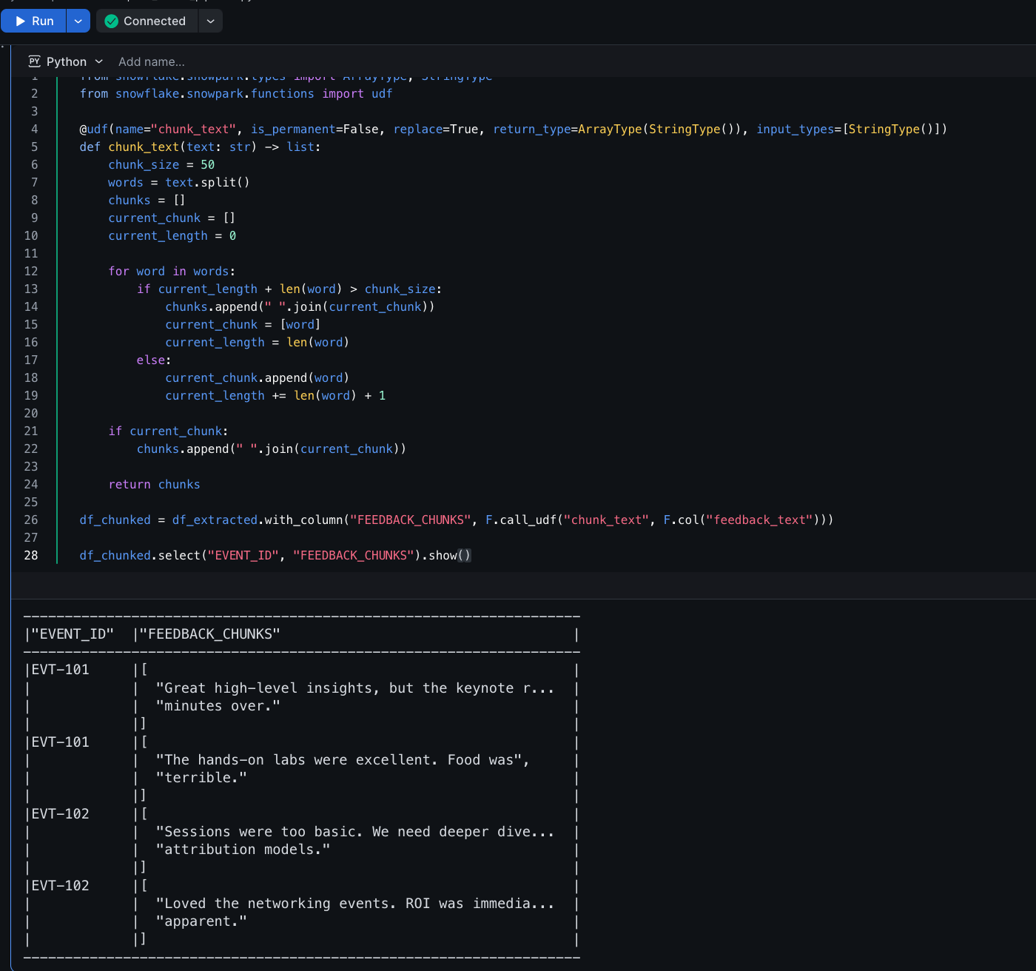

Part 5 — Persisting the Engineered Pipeline
Snowpark DataFrames utilize lazy evaluation. The data has not been modified on disk yet. We must force the execution graph to run and persist our transformed, chunked, and AI-enriched data into a new permanent table for downstream applications to consume.

Step 1 — Write DataFrame to Table
Execute the final cell to save the results.
df_chunked.write.mode("overwrite").save_as_table("event_feedback_enriched")

session.table("event_feedback_enriched").count()

Expected Output:
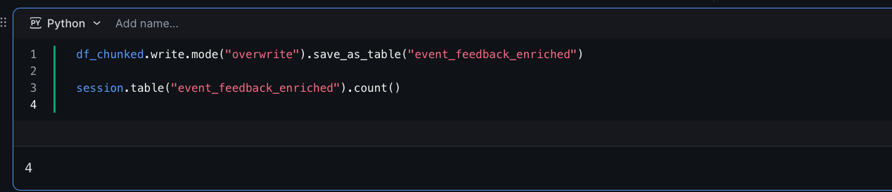
select * from event_feedback_enriched;
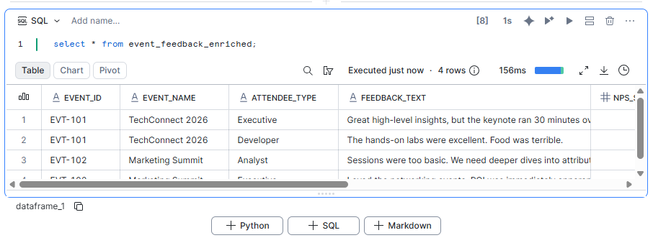

Knowledge Check
- What is the primary advantage of executing Python logic inside a Snowpark Containerized Notebook rather than a local Jupyter notebook?
  - Answer: Data Gravity and Security. The Python compute environment is provisioned directly on the Snowflake compute pool adjacent to the data, completely eliminating the need for complex networking egress, API key management, and slow data transfers over the public internet.
- Why do we need to chunk text using a custom UDF before passing data into a Vector Database or Embedding Model?
  - Answer: Embedding models have strict token limits (often 512 or 8192 tokens). If a massive document is embedded as a single vector, the semantic density is diluted. Chunking ensures that the mathematical vectors generated closely represent highly specific, easily retrievable concepts.

Clean Up
To ensure a tidy environment and prevent compute usage when idle, you can shut down your container kernel.
- Click the Connect dropdown at the top of your notebook and select Shut down kernel.

Troubleshooting

Symptom: ModuleNotFoundError: No module named 'snowflake.cortex'
Solution: You forgot to install the required libraries. Go back to the top of your notebook, create a new Python cell, run !pip install snowflake-ml-python pandas, and then re-run the cell where the import failed.

Symptom: Notebook remains stuck on "Connecting..." or fails to provision.
Solution: Container services require resources from a Compute Pool. If your assigned Compute Pool (SYSTEM_COMPUTE_POOL_CPU) has reached maximum capacity or hasn't fully spun up, the notebook may hang. Wait 2-3 minutes, or check with your account administrator to ensure your role has USAGE privileges on the selected Compute Pool.

Conclusion
In this lab, you advanced from declarative SQL to imperative Python utilizing Snowpark Notebooks running on Snowflake's Container Services. You successfully orchestrated Large Language Models programmatically via the snowflake.cortex library to perform highly structured JSON entity extraction at scale. Furthermore, you authored custom Python operations natively against your data to perform text chunking, successfully building the requisite data engineering pipeline needed for deploying robust Retrieval-Augmented Generation (RAG) applications.

